

Title of project

**Juan Navio Nunez**

**N00200925**

Software Project

Ticket selling WebPage

Year 2 2021-22

DL836 BSc (Hons) in Creative Computing

Table of Contents

1 Introduction 1

2 Business Concept 2

2.1 Business Idea 2

2.2 Business model 2

2.3 Market Research 2

2.4 Marketing/Advertising 2

2.5 Suppliers 2

2.6 Competitors 2

2.7 Employees 2

2.8 Environmental Impact 2

3 Requirements 3

3.1 Introduction 3

3.2 Requirements gathering 3

3.2.1 Similar applications 3

3.2.2 Interviews 3

3.3 Requirements modelling 3

3.3.1 Functional requirements 3

3.3.2 Non-functional requirements 3

3.3.3 Use Case Diagrams 4

3.4 Feasibility 4

4 Web application Design 6

4.1 Layout 6

4.2 Interaction 6

4.3 Colour schemes 6

4.4 Font choices 6

4.5 Wireframes 6

5 Database Design 7

5.1 Description 7

5.2 Business Reporting Requirements 7

5.3 Textual Representation of Data-Set 7

5.4 Business Rules 8

5.5 Entity Relationship Diagram 8

5.6 Tables 9

5.7 Database Dictionary 10

6 System Design/ Architecture Overview 11

6.1 Introduction 11

6.2 Model View Controller 11

6.3 User Authenticaion 11

6.4 Routing 11

6.5 Templating 11

7 Testing 12

7.1 Introduction 12

7.2 Functional Testing 12

7.2.1 Login/Registration 13

7.2.2 Navigation 13

7.2.3 Calculation 13

7.2.4 CRUD 13

7.2.5 Discussion of Functional Testing Results 14

7.3 User Testing 14

7.4 Conclusion 14

8 Project Management 15

8.1 Introduction 15

8.2 Project Phases 15

8.2.1 Requirements 15

8.2.2 Design 15

8.2.3 Implementation 15

8.2.4 Testing 15

8.3 SCRUM Methodology 15

8.4 Project Management Tools 16

8.4.1 Github Project 16

8.4.2 GitHub 16

9 Reflection 17

9.1 Your views on the project 17

9.2 How could the project could be developed further? 17

9.3 Assessment of your learning. 17

9.4 Completing a large software development project 17

9.5 Technical skills 17

9.6 Further competencies and skills 17

10 References 18

# Introduction

The aim of this project is to create a web application which will help me to develop my skills using different languages as PHP, MySQL, Bootstrap, CSS, Sass, html and js.

The original idea is a concert/festival ticket selling webpage, where all the discographic business or independent artist can sell their tickets

# Business Concept

## Business Idea

The original idea is a concert/festival ticket selling webpage, where all the discographic business or independent artist can sell their tickets I’m aiming to have a web application with dynamism and easy to use, a site where you can go in and have a fast buy without too many hesitations.

## Business model

My business will be able to make the ticket selling easy and fast for the sellers and for the users.

The business will take a small percentage of the tickets sold, plus different incomes from advertising, etc…

## Weakness / Threats

The competitors are very weak and not trying enough to make this business bigger than already is, so the only thing I could say is a treat is not being famous enough between the existing business, luckily, I think it won’t take long to change this.

## Market Research

My business marketing would be basically all online, having advertising in other platforms such as YouTube or Twitch where I can find targets in the age range I’m looking for, younger generations.

## Competitors

The main competitors would be the other selling web pages such as TicketMaster or StubHub.

# Requirements

### Functional requirements

The sellers would be able to “post their tickets” and the buyers would be able to see them online so they are able to make a buy fast and save.

### User requirements

User will be able to buy the tickets or in the case they are the sellers they can sell their tickets for their own events.

### Use Case Diagrams

## Feasibility

For my feasibility I will use: GitHub, Figma, Bootstrap and Laravel.

# Web application Design

## Layout

For the layout I used Figma, using basic rectangles to make my page minimalist and clean.

## Interaction

The webpage will have interaction for selling the tickets and for buying them.

## Colour schemes

For my color schemes I used 5 colours.

## Font choices

For my font choices I will use Raleway, which I found attractive for my page.

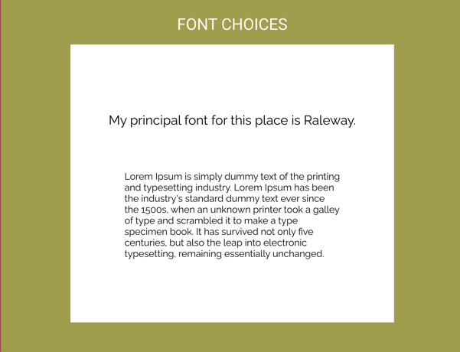

## Wireframes

Homepage mid-fidelity

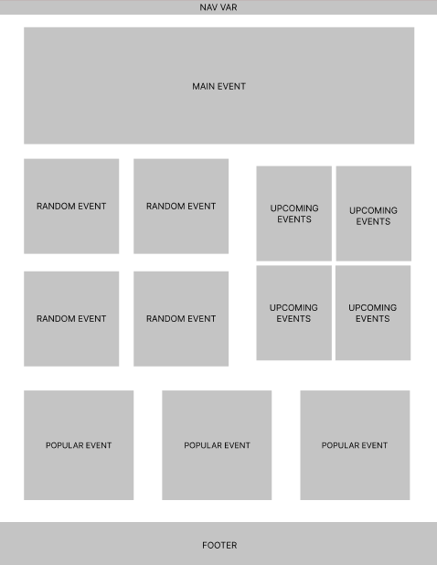

**Homepage high-fidelity**

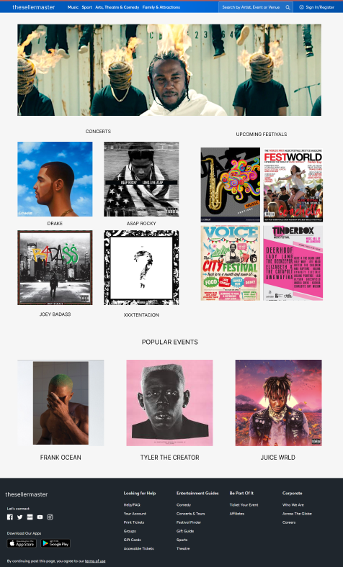

# Database Design

## Description

My page will have a database connected to it to store the tickets of the events.

## Textual Representation of Data-Set

**roles**  (id, name, description, created_at, updated_at)

**tickets** (id, title, description, location, start_time, created_at, updated_at)

**users** (id, name, email, email_verified_at, password, remember_token, created_at, updated_at)

**user_role** (id, user_id, role_id, created_at, updated_at)

## Tables

## Database Dictionary

|  |  |  |  |  |  |  |
| --- | --- | --- | --- | --- | --- | --- |
| roles | Attribute | Datatype | Range | Required | PK/FK | FK Ref Table |
| id | unsigned | bigint | 20 |  | PK |  |
| Name |  | varchar | 255 |  |  |  |
| Description |  | varchar | 255 |  |  |  |
| Created_at |  |  |  |  |  |  |
| Updated_at |  |  |  |  |  |  |

|  |  |  |  |  |  |  |
| --- | --- | --- | --- | --- | --- | --- |
| Tickets | Attribute | Datatype | Range | Required | PK/FK | FK Ref Table |
| id | unsigned | bigint | 20 |  | PK |  |
| title |  | varchar | 255 |  |  |  |
| description |  | varchar | 255 |  |  |  |
| location |  | varchar | 255 |  |  |  |
| Start_time |  | date |  |  |  |  |
| Created_at |  | timestamp |  |  |  |  |
| Updated_at |  | timestamp |  |  |  |  |

|  |  |  |  |  |  |  |
| --- | --- | --- | --- | --- | --- | --- |
| users | Attribute | Datatype | Range | Required | PK/FK | FK Ref Table |
| id | unsigned | bigint | 0-100 |  | PK |  |
| name |  | varchar | 2555 |  |  |  |
| email |  | varchar | 255 |  | FK |  |
| Email_verified_at |  | timestamp |  |  |  |  |
| password |  | varchar | 255 |  |  |  |
| Remember_tocken |  | varchar | 100 |  |  |  |
| Created_at |  | timestamp |  |  |  |  |
| Updated_at |  | timestamp |  |  |  |  |

|  |  |  |  |  |  |  |
| --- | --- | --- | --- | --- | --- | --- |
| User_role | Attribute | Datatype | Range | Required | PK/FK | FK Ref Table |
| id | unsigned | bigint | 20 |  | PK |  |
| User_id | unsigned | bigint | 20 |  | FK | users |
| Role_id | unsigned | bigint | 20 |  | FK | roles |
| Created_at |  | int |  |  |  |  |
| Updated_at |  | int |  |  |  |  |

# Project Management

## Introduction

Project Management for this web page was a very important part of the process to make a proper and professional site.

## Project Phases

### Design

The design of my project started from a simple drawing on paper to the mid-fidelity and finally the high-fidelity using figma for this last two.

## Project Management Tools

### Github Project

For GitHub I committed every time I had an update in my project

### GitHub

I created a repository in GitHub that every time I had an update of my project I commit the changes so I have a progress of my work.

# Reflection

## Your views on the project

This project was very successful from my point of view

## How could the project could be developed further?

If I had more time I would love to develop a little bit more my SQL skills and Laravel skills aswell.

## Assessment of your learning.

I think I learned enough to be competitive in my sector, having no questions or doubts about anything and having a very good development of my skills

## Completing a large software development project

It was very challenging for the reason that I didn’t have enough time to put more effort in the project despite the good work I think I did.

## Technical skills

I think I’m very competent and my skills are on point, having under control languages as SQL, HTML, CSS, and using successfully Laravel.

## Further competencies and skills

I hope in a future I would be able to improve even more my skills.

# References

## Frameworks:

**Laravel:**

<https://laravel.com/>